Introduction to Artificial Neural Networks (ANN) :

Artificial Neural Networks (ANNs) are a fundamental component of deep learning, a subfield of machine learning inspired by the human brain. ANNs are composed of interconnected nodes, or "neurons," structured in layers that process and transform data to recognize patterns and make predictions.

Key Components of an ANN:

Input Layer: Receives the raw data that will be processed.

Hidden Layers: Perform complex transformations on the input data using weights, biases, and activation functions.

Output Layer: Provides the final prediction or classification result.

Weights and Biases: Learnable parameters that are updated during training to improve the model's accuracy.

Activation Functions: Introduce non-linearity to the network, enabling it to learn complex patterns.

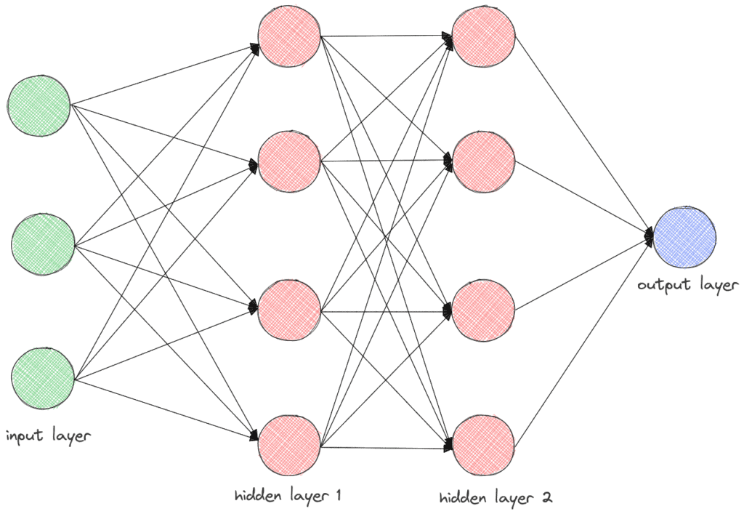

How ANNs Work:

Data Processing: Input data is fed through the network layer by layer.

Forward Propagation: Each neuron performs weighted summation followed by an activation function, passing the result to the next layer.

Error Calculation: The difference between the predicted and actual output is measured using a loss function.

Backpropagation: The error is propagated backward to adjust weights and biases, optimizing the network for better performance.

Training: The network iteratively updates its parameters through optimization techniques like gradient descent.

Applications of ANNs in Deep Learning:

Image and speech recognition

Natural language processing (NLP)

Autonomous vehicles

Medical diagnostics

Financial market predictions

The flexibility and power of ANNs have made them essential in solving complex problems and advancing AI applications.

**Types of Hidden Layers in Artificial Neural Networks**

**1. Dense (Fully Connected) Layer**

A dense layer is the most common type of hidden layer in an ANN. Every neuron in a dense layer is connected to every neuron in the previous and subsequent layers. This layer performs a weighted sum of inputs and applies an activation function to introduce non-linearity. The [activation function](https://www.geeksforgeeks.org/activation-functions-neural-networks/) (like [ReLU](https://www.geeksforgeeks.org/why-is-relu-used-as-an-activation-function/" \t "_blank), [Sigmoid](https://www.geeksforgeeks.org/derivative-of-the-sigmoid-function/), or Tanh) helps the network learn complex patterns.

**Key Points:**

* **Role**: Learns representations from input data.
* **Function**: Performs weighted sum and activation.
* **Example**: Common in fully connected neural networks.

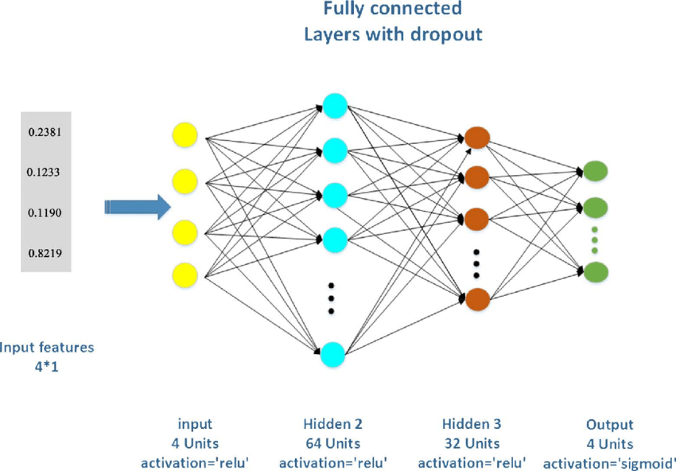

**2. Convolutional Layer**

Convolutional layers are primarily used in [Convolutional Neural Networks (CNNs)](https://www.geeksforgeeks.org/convolutional-neural-network-cnn-in-machine-learning/) for image processing tasks. They apply convolution operations to the input, capturing spatial hierarchies in the data. Convolutional layers use filters to scan across the input and generate feature maps. This helps in detecting edges, textures, and other visual features.

**Key Points:**

* **Role**: Extracts spatial features from images.
* **Function**: Applies convolution using filters.
* **Example**: Detects edges and textures in images.

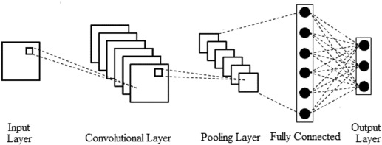

**3. Recurrent Layer**

Recurrent layers, such as [Long Short-Term Memory (LSTM)](https://www.geeksforgeeks.org/deep-learning-introduction-to-long-short-term-memory/) and [Gated Recurrent Unit (GRU),](https://www.geeksforgeeks.org/gated-recurrent-unit-networks/) are used in [Recurrent Neural Networks](https://www.geeksforgeeks.org/introduction-to-recurrent-neural-network/) (RNNs) for sequence data like time series or natural language. They have connections that loop back, allowing information to persist across time steps. This makes them suitable for tasks where context and temporal dependencies are important.

**Key Points:**

* **Role**: Processes sequential data with temporal dependencies.
* **Function**: Maintains state across time steps.
* **Example**: Language modeling, time series prediction.

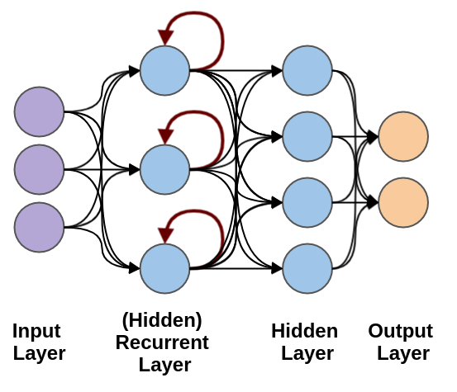

**4. Dropout Layer**

[Dropout layers](https://www.geeksforgeeks.org/dropout-in-neural-networks/) are a [regularization](https://www.geeksforgeeks.org/regularization-in-machine-learning/) technique used to prevent overfitting. They randomly drop a fraction of the neurons during training, which forces the network to learn more robust features and reduces dependency on specific neurons. During training, each neuron is retained with a probability ppp.

**Key Points:**

* **Role**: Prevents overfitting.
* **Function**: Randomly drops neurons during training.
* **Example**: Common in[deep learning](https://www.geeksforgeeks.org/deep-learning-tutorial/) models to improve generalization.

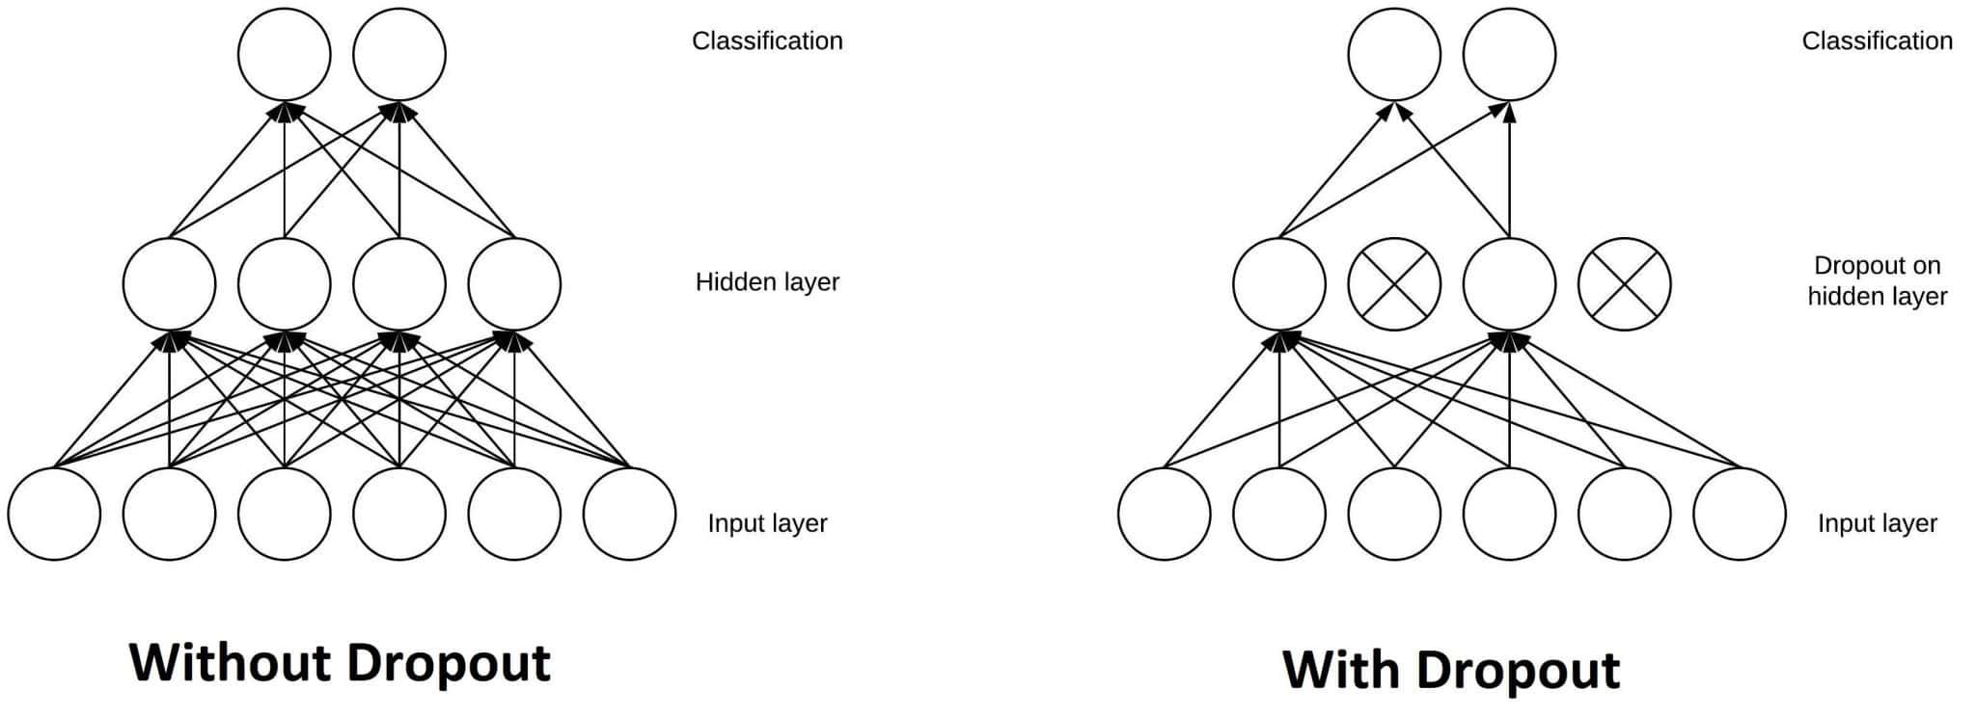

**5. Pooling Layer**

A [**Pooling Layer**](https://www.geeksforgeeks.org/cnn-introduction-to-pooling-layer/) is used to reduce the spatial dimensions of the data, thereby decreasing the computational load and controlling overfitting. Common types of pooling include Max Pooling and Average Pooling.

**Use Cases:** Dimensionality reduction in CNNs

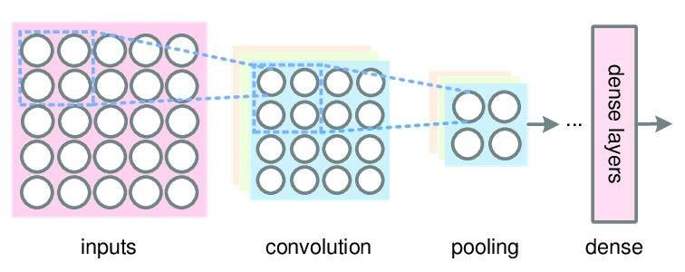

**6. Batch Normalization Layer**

A [**Batch Normalization Layer**](https://www.geeksforgeeks.org/what-is-batch-normalization-in-cnn/) normalizes the output of a previous activation layer by subtracting the batch mean and dividing by the batch standard deviation. This helps in accelerating the training process and improving the performance of the network.

**Use Cases:** Stabilizing and speeding up training

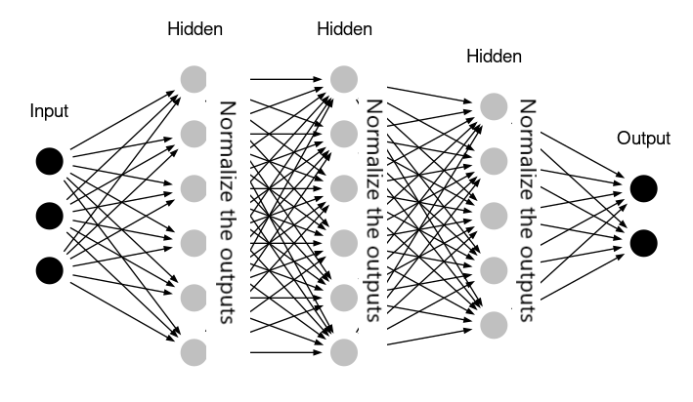

**Conclusion**

Understanding the different types of layers in an ANN is essential for designing effective neural networks. Each layer has a specific role, from receiving input data to learning complex patterns and producing predictions. By combining these layers, we can build powerful models capable of solving a wide range of tasks.

By mastering the use of input, hidden, and output layers, you can create sophisticated ANNs tailored to your specific needs, whether you're working on image recognition, natural language processing, or any other data-driven task.